Figure Content Analysis for Biomedical Article Retrieval

Daekeun Youª, Emilia Apostolova^{b}, , Dina Demner-Fushman,
George R. Thoma

National Library of Medicine, National Institutes of Health, Bethesda, MD 20894
ª Dept. of Computer Science and Engineering, The State University of New York, Buffalo, NY 14260
^{b} College of Computing and Digital Media, DePaul University, Chicago, IL 60604

Abstract

Biomedical images are invaluable in establishing diagnosis, acquiring technical skills, and implementing best practices in many areas of medicine. At present, images needed for instructional purposes or in support of clinical decisions appear in specialized databases and in biomedical articles, and are therefore not easily accessible. Our goal is to automatically annotate images extracted from scientific publications with respect to their usefulness for clinical decision support and instructional purposes, and project the annotations onto images stored in databases by linking images through content-based image similarity.

Authors often use text annotations and pointers on figures and illustrations in the articles to indicate regions of interest. These annotations are then referenced in the caption text or figure mention. In previous research we have obtained 95.54% accuracy in correctly identifying and segmenting the sub-figure images from multi-panel images. Further, we have reported an accuracy of 72.02% in localization of text and symbols on extracted panel images. Content extraction in images has traditionally relied on applying image feature extraction techniques applied on entire images or on pre-determined regions on images. Such approaches are often unsuccessful in capturing content-semantics in figure images in articles due to the large variety of images in the published literature.

Our approach to addressing this problem is by combining (i) analysis of caption and other text analysis using natural language processing methods and (ii) extracting pointers (arrows and other annotation symbols) from figure images. Biomedical concepts in extracted snippets of text pertaining to images in scientific biomedical articles (image captions and relevant discussion in the text) are derived from National Library of Medicine’s Unified Medical Language System® (UMLS ®) Metathesaurus. Localizing and identifying pointers, arrows, and other annotation symbols can then be used to measure meaningful image content that can then be tagged with the derived concepts for improved (text and image) content-based retrieval of biomedical articles.

1. Introduction

Essential information is often conveyed in illustrations in biomedical publications. These images can be used to illuminate document summaries and answers to clinical questions, to enrich large image collections with textual information from articles, and for instructional purposes. The problem, however, is to automatically determine which of the images in an article will best serve each of the aforementioned purposes. Our approach to automatic image indexing is to describe (or annotate) an image at three levels of granularity:

- coarse, which addresses
  - image modality,
  - relation to a specific clinical task (image utility),
  - body location;
- medium, which provides a more detailed description of the image using existing biomedical domain ontologies;
- specific, which provides very detailed descriptions of clinical entities and events in an image using terms that are not included in existing ontologies and often are familiar only to clinicians specializing in a narrow area of medicine.
Clinicians and medical researchers routinely use online databases such as MEDLINE® to search for bibliographic citations that are relevant to a clinical situation. They can fairly accurately form an opinion about the relevance of a publication to the clinical situation based on its title alone; however the title is not always sufficient in determining the evidence-based practice usefulness (henceforth evidence-based utility or clinical utility) of a publication [1]. Our prior research [2, 3, 4] has shown the value in extracting relevant text and figure information from articles to determine coarse and medium level annotations for images in biomedical articles. Initial efforts in obtaining specific content in figure images by localizing text on figure images and correlating it with article text was reported in [3].

Authors often put several other forms of annotations on images. These include pointers (e.g., arrows and arrowheads), symbols (e.g., asterisk), solid and dashed lines. These are usually used to identify a region of interest in the image that is then discussed further in the article. Thus, extracting these symbols may assist in identifying the region of interest within the image where images features could be measure for effective (and possibly semantically relevant) content-based image retrieval. This article presents our initial efforts in localizing and recognizing such pointers. Image regions pointed to by these pointers are then used for indexing images and are also tagged by biomedical concepts extracted from relevant text snippets.

The remainder of the article is organized as follows. Section 2 provides a brief background of our previous work on the subject. Section 3 describes the methods and presents initial results. This effort is a work-in-progress and we expect to provide updated results on this challenging task in the final version of this article. Section 4 lists the challenges and current conclusions.

2. Background

In our previous exploration of coarse automatic indexing of images by modality (color image, gray-scale image, graph, graphic illustration, etc.) and image utility (suggested by the Evidence Based Medicine paradigm six elements of a clinical scenario that an image might illustrate), we combined image and textual features in a supervised machine learning approach. Textual features were obtained from the captions to the images and paragraphs of text containing discussion (“mentions”) of these images. The text and the images were automatically extracted from the HTML-formatted articles. Text was represented as a bag-of-words or as a set of terms obtained by mapping these captions and mentions to the UMLS Metathesaurus. Texture and color features were computed on the entire image without applying any image segmentation techniques.

Texture features were computed as a 3-level discrete 2-D Daubechies’ wavelet transform. The four most dominant colors were computed in the perceptually uniform CIE LUV color space and proved most effective. At this coarse level of granularity, a multi-class SVM classifier trained on a bag-of-words representation of image captions performed better in determining image modality (84.3% ± 2.6% accuracy) than when trained on a combination of textual and image features or features reduced to the domain specific vocabulary. For image utility, however, the combination of image and textual features was better than any single-source feature set achieving 76.6% ± 4.2% accuracy [2].

Often in biomedical publications, several images are combined into a multi-panel figure. This requires sub-figure separation for image analysis to determine image modality. We therefore developed a two-phase algorithm to detect and separate figure panels using cues from caption text analysis, horizontal and vertical profiles and panel edge information [3]. Further analysis on each image panel revealed its coarse modality. For instance, using color histogram profiles we could determine with sufficient precision if an image is a color image, an illustration/drawing, or a radiographic image (CT, MRI, x-ray, sonogram, etc.). Detecting image modalities is useful in further image analysis and sub-categorization. Our efforts in this area resulted in development of a method for detecting text overlays on images, arrows, and other content valuable for indexing images by visual content and correlated text description [3]. We reported 95.54% accuracy in correctly identifying and segmenting the sub-figure images from multi-panel images and an accuracy of 72.02% in localization of text and symbols on extracted panel images.

3. Methods

A challenge in information retrieval is finding specific information with high precision. In base our approach for retrieving biomedical articles using a combination of image and text features by cascading application of text and image feature matching methods. We are operating on the observation that text retrieval can excel in reducing the search space for a cascaded application of image retrieval and consequently improve accuracy in biomedical information retrieval.

3.1 Data

The data for this experiment was obtained from Radiology and Radiographics journals published by the Radiological Society of North America (RSNA). The data set has over 5,000 articles comprising of over 67,000 images. A coarse categorization indicated that a large proportion (approximately 50,500) images are grayscale and potentially radiological. Illustrations and color images were approximately 7,500 and 9,000, respectively.

3.2 Text Snippet Processing

As indicated earlier, extracting and processing snippets of text relevant to images, such as captions and lines of text surrounding each discussion of a figure in a paragraph (mentions), can greatly assist in improving retrieval accuracy. The HTML formatting of the articles in the journals is relatively uniform and well structured, which allowed use of regular expressions to extract figure captions and mentions. Additional patterns were developed to identify parts of captions corresponding to panels of the multi-panel images. In case of an error in panel identification, the extracted caption and paragraph text was duplicated for each panel. The following steps are under development in this area:

- Detection of keywords describing or identifying a pointer, e.g., “arrow”, “bold white line”, “red star”, “label A”, etc.
- Extraction of UMLS concepts for the entire caption and, if applicable, to the entity pointed to.

A quick analysis of caption text revealed over 2500 instances of “arrow” in the text. Such information can be very valuable in indicating the presence, color, size, and sometimes, even shape, of the pointer.

3.3 Pointer Detection

As indicated previously, we have coarsely divided images into three categories, viz., illustrations, grayscale images, and color images. For initial experiments we are considering only color and gray scale images. This is for the following practical reasons:

- Illustrations tend to have relatively low diagnostic illustrative utility. In that sense, they offer little to compute for CBIR purposes. They have high instructional value, however. Additionally, recognizing text on such images would be very valuable.
- It is relatively easy to segment lines and pointers from the background in illustration images. Although, it is challenging to identify which lines are truly pointers in a line diagram.
- There are more color and grayscale images in our data set.

Pre-processing: The method operates on a gray scale image and converts any color image into a gray scale. Edge detection is performed using the Roberts mask [5]. The edge image is adaptively binarized using average values of global and local threshold that are computed using two methods: Otsu [6], and Kittler and Illingworth [7]. The global threshold is computed from the whole image and the local threshold is computed from each 64*64 sub-image. The boundaries are then converted to 8-direction chain code [8]. Boundaries smaller than 64 points are discarded on the observation that such small arrows are unlikely to be found in these images.

Arrow finding and classification: Following from prior work in object recognition [9, 10, 11], we apply Fourier descriptors to localize and recognize arrows in images. It is possible to discriminate several different shapes of arrow commonly used in biomedical images. Evenly spaced (sampled) boundary points are used to compute the Fourier coefficients. We discard the first Fourier coefficient (the centroid) and use the next term to normalize remaining 62 coefficients that are then used for classification. Figure 1 shows the results of this approach applied to an image.

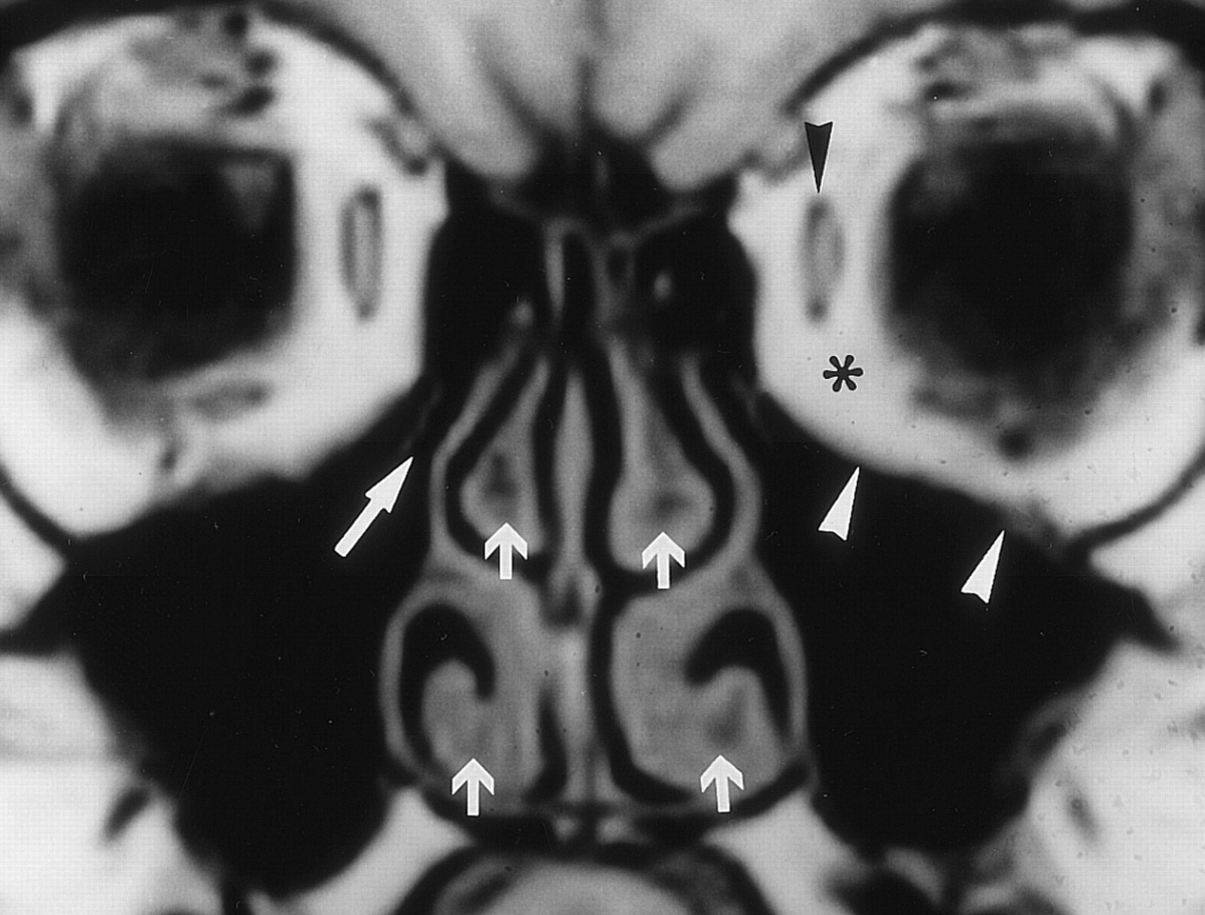 | 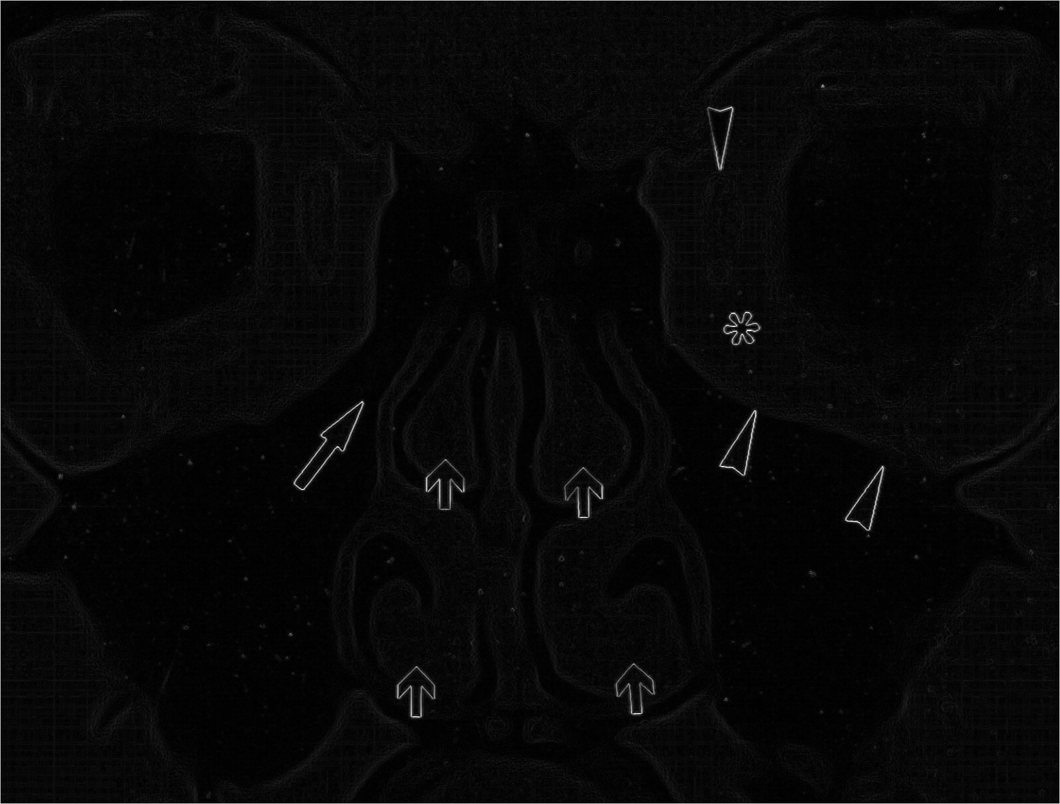
(a) | (b)
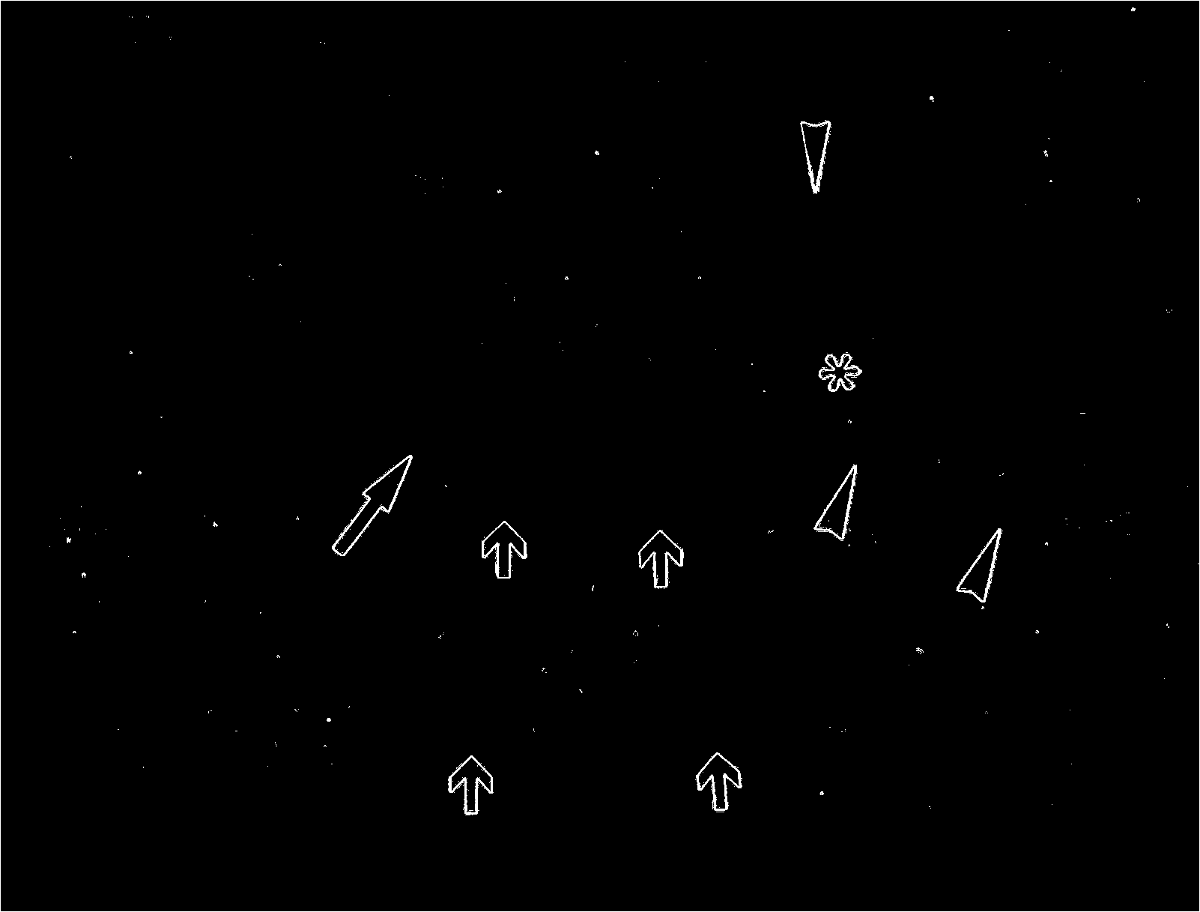 | 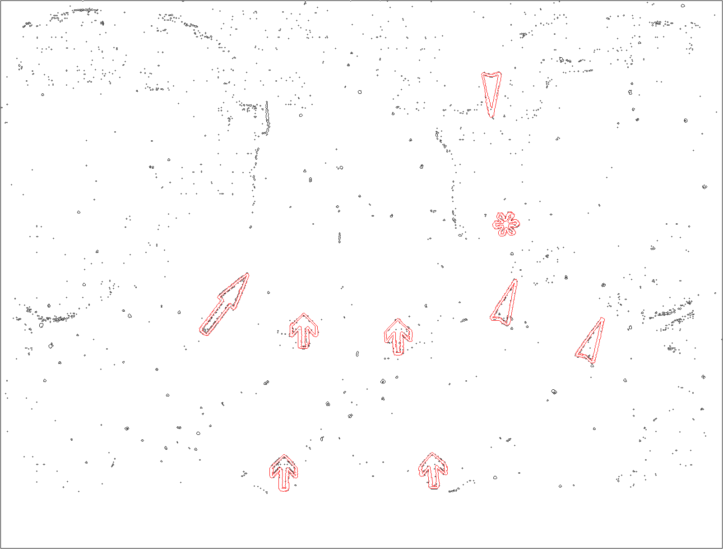
(c) | (d)
Figure 1. Preliminary arrow finding result. (a) Original image with 5 arrow/pointers; (b) Edge detection results; (c) Binarization results; (d) Classification results shown in red.

Challenges: With initial success in localizing and recognizing arrows / pointers in images, we also notice many challenging cases. These can be grouped into two broad classes, viz., images with noisy background and segmenting steps resulting in broken arrows. These cases are illustrated below.

- Noisy Images: There are several instances of images with noisy background where it becomes difficult to separate arrows from background images. This is especially challenging if the image is gray scale at source. Uniform color on arrows may make this task more tractable in color images. For gray scale images we are considering applying morphological operations. In general, we believe that noise boundaries should be removed before computing Fourier Descriptors and classification steps. Examples of an image and arrow segmentation results with complex background are shown in Figure 2(a) and 2(b), respectively. Example results for images where background noise was successfully removed are shown in Figure 3.

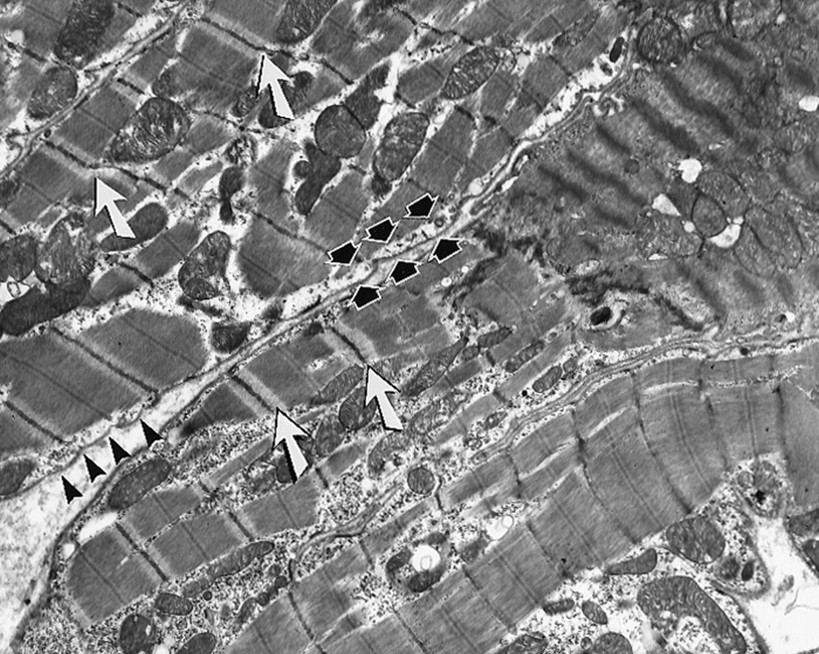 | 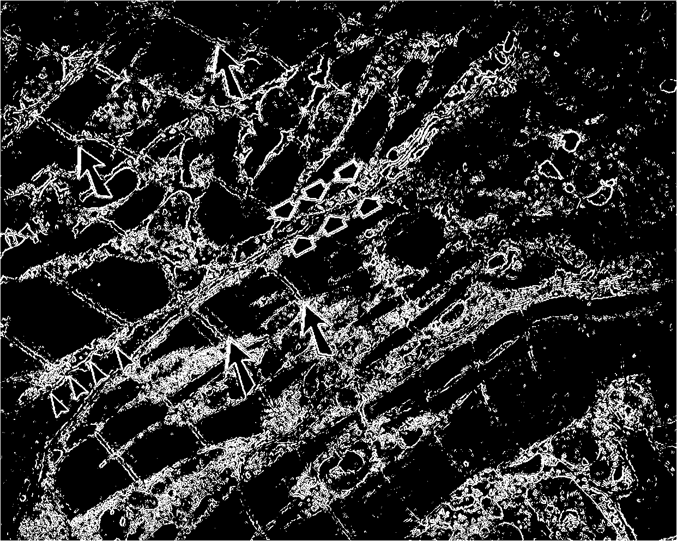
(a) | (b)
Figure 2. Arrow segmentation on images with noisy content; (a) Original image; (b) Edge image.
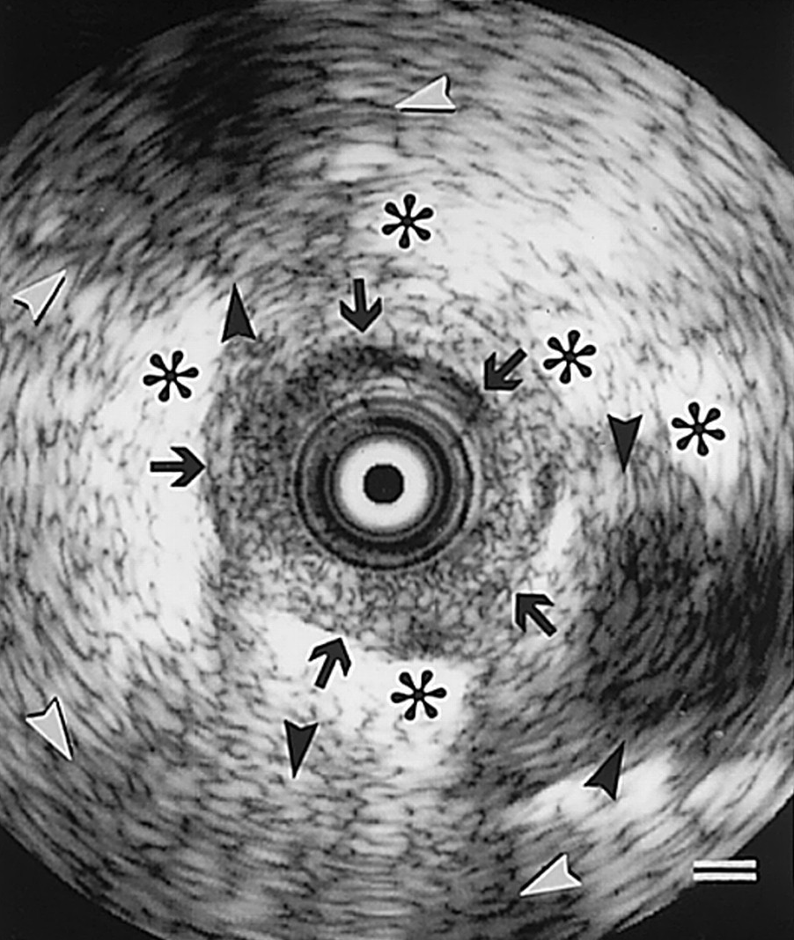 | 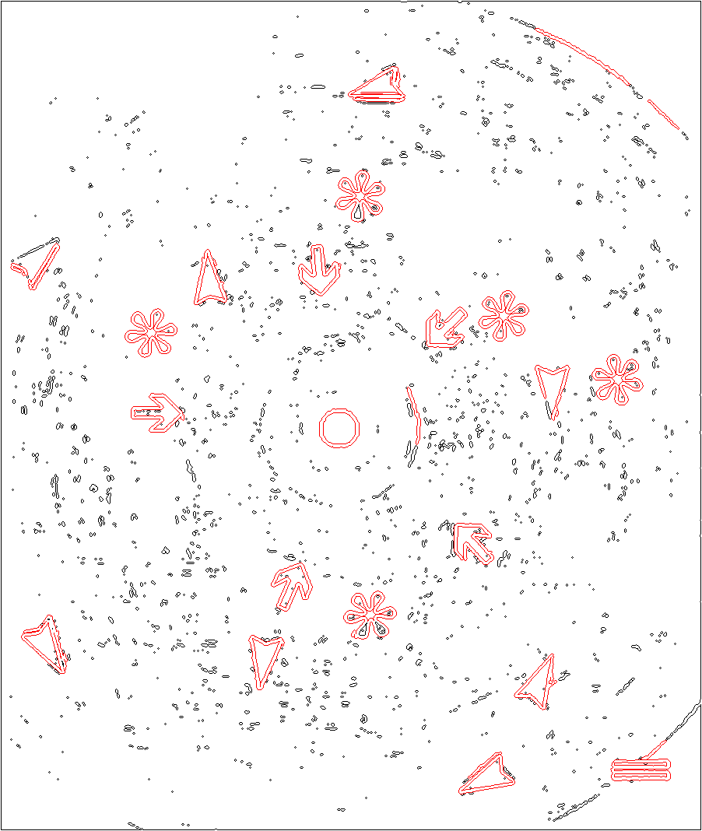 | 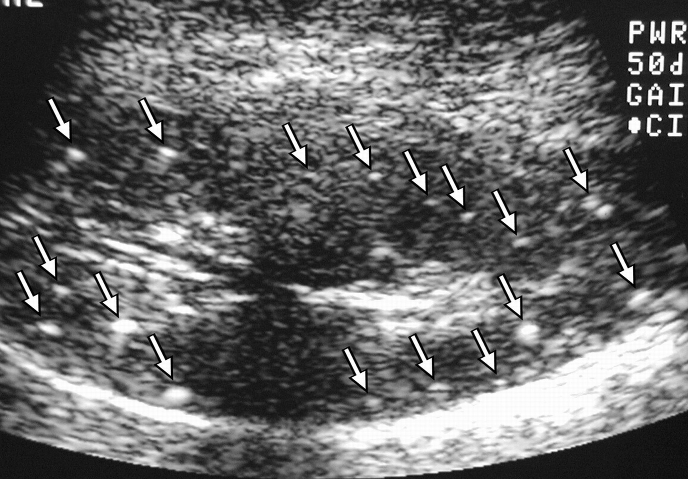 | 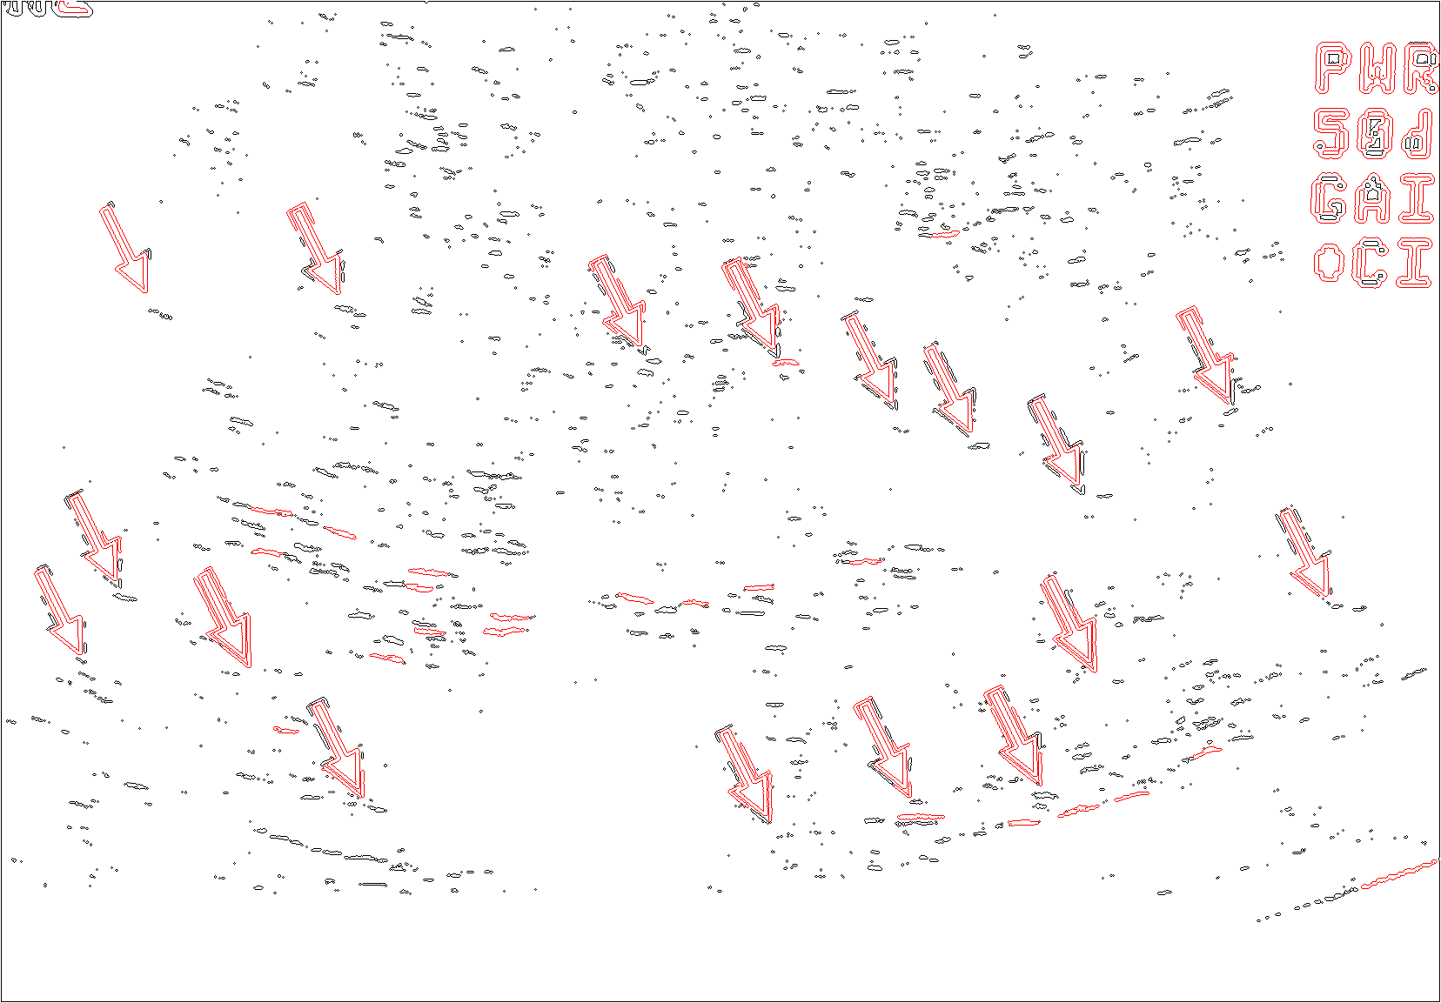
(a) |  | (b)
Figure 3. Results of arrow and pointer classification after successful noise removal in gray scale images.

- Broken Boundary, Altered Shape From Touching Edges: Another challenging problem is that of broken arrow or pointer boundaries. This can occur due to weak arrow boundaries (edge thickness) or being overlaid on regions of similar color or intensity. Broken boundaries or malformed arrows can also be a side-effect of noise removal steps which can thin edges or result in stray edge fragments touching the arrow or pointer. Examples of these are shown in Figure 4, below. Potential solutions include development of more robust arrow recognition techniques possibly based on machine learning approaches rather than strict thresholding of Euclidean distance measures between candidate shape features and pre-computed templates.

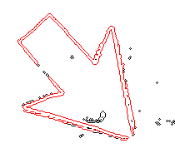 | 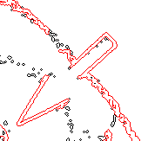 | 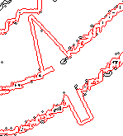
(a) | (b) | (c)
Figure 4. Arrow classification results showing: (a) arrow with broken boundary; (b) effect of noise removal; (c) overlap with similar region.

4. Conclusions and Work in Progress

Detecting arrows, pointers, and other annotations such as text labels, can be very beneficial in locating regions of interest within figures in biomedical articles. Such annotations can be identified through relevant text snippet analysis (captions, mentions) and image analysis methods. Text concepts as well as image features can now be used to tag image content. We expect this to improve image indexing quality and consequently biomedical article indexing and retrieval.

Proposed methods and initial results show promise. Some ongoing efforts to address the stated challenges include using color information in localizing and recognizing arrows. Not only could color image segmentation address some background noise problems, but also improve text analysis has shown that authors have often indicated the presence of such annotation by referring to a “red arrow”, “white line”, or “yellow pointer”. Other, approaches include application of machine learning, use of contextual knowledge (arrow shape, presence of straight lines, sharp corners, etc.), and other image characteristics to improve recognition robustness in cases of broken arrows or touching regions. We continue to explore these methods and propose to provide updated results in the final version of this article.

Acknowledgement

This research was supported by the Lister Hill National Center for Biomedical Communications and intramural R&D division of the National Library of Medicine, at the National Institutes of Health, U.S. Department of Health and Human Services.

References

- Demner-Fushman D, Hauser S, Thoma G. The role of title, metadata and abstract in identifying clinically relevant journal articles. AMIA Annu Symp Proc; 2005:191-5.
- Demner-Fushman D, Antani SK, Thoma GR. Automatically Finding Images for Clinical Decision Support. Proceedings of Worshop on Data Mining in Medicine, 7th IEEE Intl Conf on Data Mining 2007:139-44.
- Antani S, Demner-Fushman D, Li J, Srinivasan BV, Thoma GR. Exploring use of images in clinical articles for decision support in Evidence-Based Medicine. Proc. SPIE-IS&T Electronic Imaging. San Jose, CA. January 2008;6815:68150Q(1-10)
- Demner-Fushman D, Antani SK, Simpson M, Thoma GR. Combining Medical Domain Ontological Knowledge and Low-level Image Features for Multimedia Indexing. Proc. 2nd International "Language Resources for Content-Based Image Retrieval" Workshop (OntoImage 2008), part of 6th Language Resources and Evaluation Conference (LREC 2008). 2008;CDROM Proceedings
- Sonka M, Hlavac V, Boyle R. Image Processing, Analysis, and Machine Vision, Thomson-Engineering, 2007
- Otsu N. A Threshold Selection Method from Gray-Level Histograms. IEEE Trans Systems, Man, and Cybernetics. 9(1):62-6, 1979.
- Kittler J, Illingworth J. Minimum error thresholding. Pattern Recognition. 19:41–7, 1986.
- Freeman H. On the encoding of arbitrary geometric configurations. IRE Trans. Electronic Computers, 260-8, 1961
- Sarfraz, M. Object Recognition using Fourier Descriptors: Some Experiments and Observations. in Computer Graphics, Imaging and Visualisation, 2006 International Conference on. 2006.
- Loncaric, S. A survey of shape analysis techniques. Pattern Recognition, 1998. 31(8):983-1001.
- Folkers, A., Samet H. Content-based image retrieval using Fourier descriptors on a logo database. Proc. 16th Intl. Conf on Pattern Recognition, 2002.

