LSP 121
Answers to Midterm Exam Study Guide

Databases
1. Create a database for recording season tickets for the DePaul basketball program. A customer can purchase one or more tickets (seats). You should record the customer’s last name, address, city, state, and zip, and then a list of each ticket that has been sold to this customer (row number, seat number, date of game, cost of ticket). Go ahead and create 3 customers, with the first customer (from Chicago) purchasing 2 tickets, the second customer (from Lombard) purchasing 4 tickets, and the third customer (from Chicago) purchasing 1 ticket. Copy and paste all tables into your Word document.

Season Ticket Holder Info
Last Name | Address | City | State | Zip | ID
Smith | 123 Oak | Chicago | IL | 60606 | 123
Jones | 234 Elm | Lombard | IL | 60304 | 234
Kingsfield | 345 Pine | Chicago | IL | 60604 | 345

Tickets
ID | Row Number | Seat Number | Date of Game
123 | 44 | 12 | 5/5/2010
123 | 44 | 13 | 5/5/2010
234 | 8 | 43 | 5/9/2010
234 | 8 | 44 | 5/9/2010
234 | 8 | 45 | 5/9/2010
234 | 8 | 46 | 5/9/2010
345 | 112 | 5 | 6/2/2010

Note ID is defined as Primary Key in first table and is type Text. ID also appears in second table, is not defined as a Primary Key, and is also Text (thus making it a Foreign Key).
2. Using the season ticket database from above, create a form that will allow someone to enter and view the records and sub-records. Copy and paste one example of this form to your Word document.

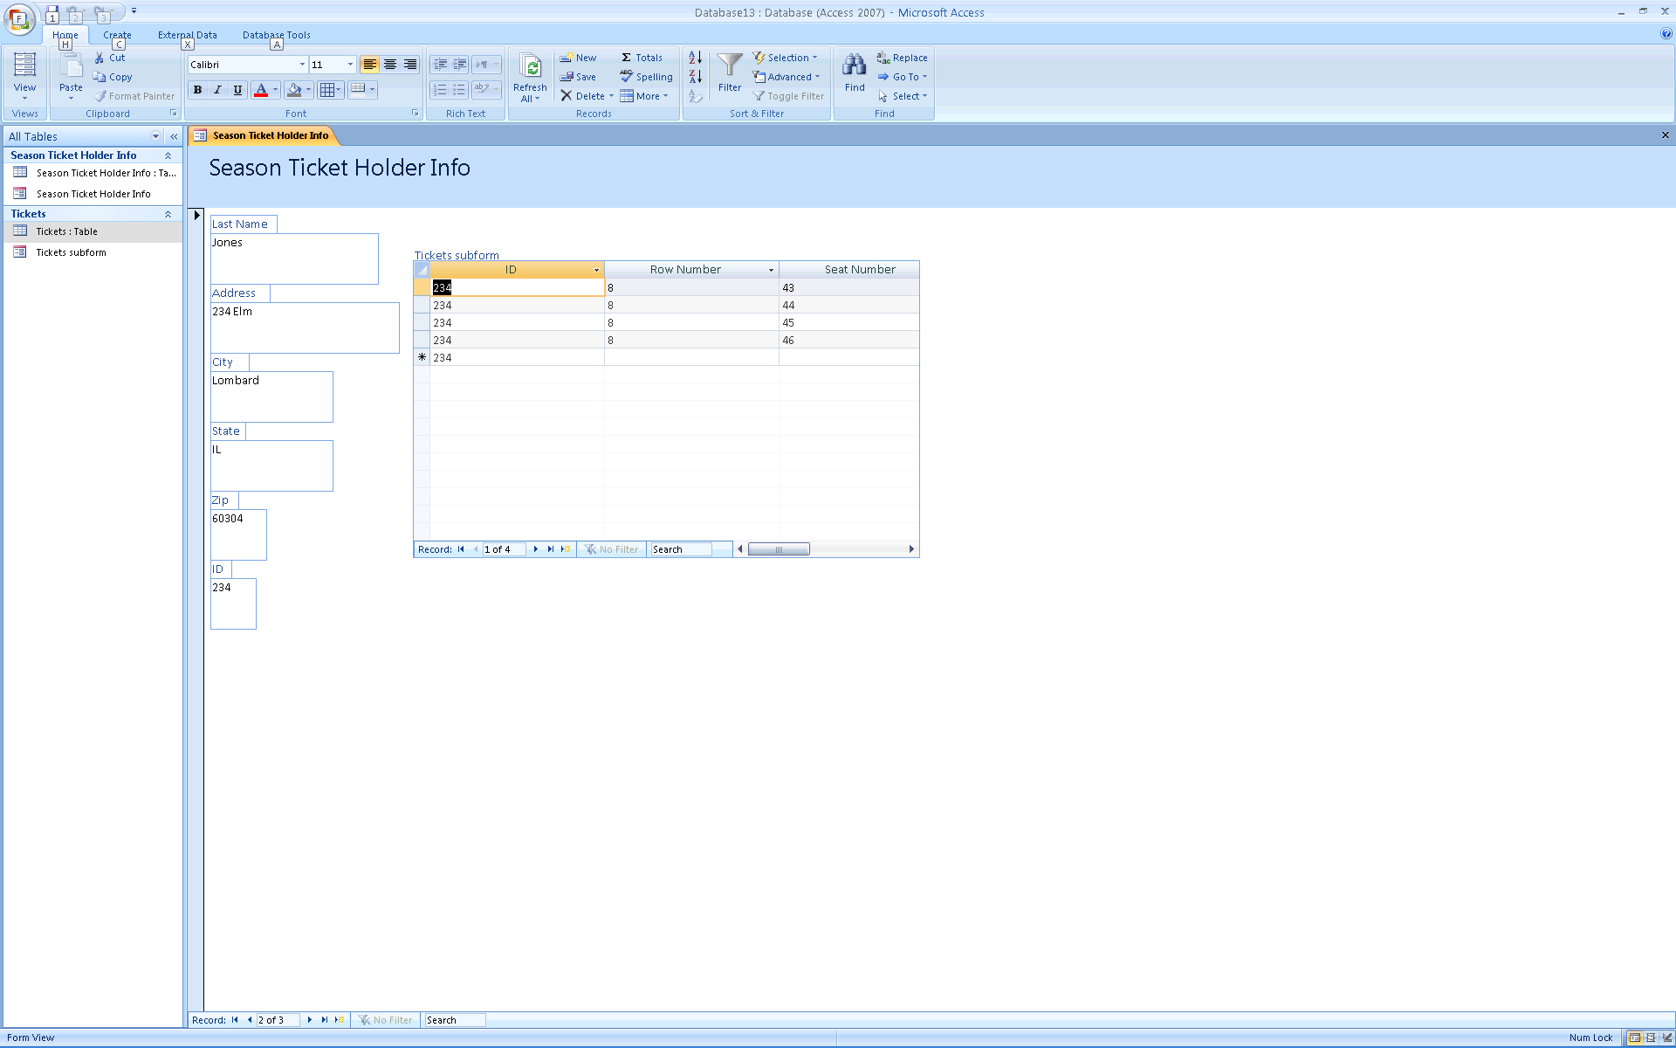

3. Using the same season ticket database, create a report that lists each customer along with each seat assignment. Group records by city. Copy the report and paste into your Word document.

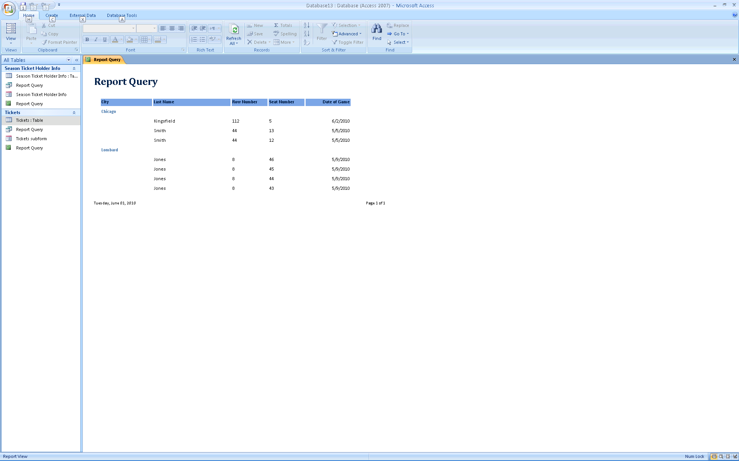

Make a query first that lists last name, city, row number, seat number and date of game. Then make a report based on that query. Group by City.

4. Perform the query that displays customer last name and address for all customers living in Chicago. Copy and paste the query results into your Word document.

Query1
Last Name | Address
Smith | 123 Oak
Kingsfield | 345 Pine

5. Perform the query that displays customer last name, address, and each seat assignment for all customers living in Chicago.

Query2
Last Name | Address | Row Number | Seat Number
Smith | 123 Oak | 44 | 12
Smith | 123 Oak | 44 | 13
Kingsfield | 345 Pine | 112 | 5

6. Create a database for the local automobile repair center. Customer info should include Customer ID, Last Name, First Name, Address, City, State, and Zip. Each customer can have multiple cars. Each car record should include Car ID, Model, Make, and Year. Each car can come in for multiple service appointments. Each service appointment should have Service ID, Date, Repair Performed, Cost, and Is It Under Warranty. Create 3 customer records. For the first customer, create 2 autos. For the first auto, create 3 service records. Copy and paste all tables into your Word document.

Basic Demographic
Customer ID | Last Name | First Name | Address | City | State | Zip
1 | Jones | Sue | 123 Main | Elmhurst | IL | 60043
2 | Zygote | Zyggy | 4943 Lincoln | Park Forest | IL | 63303
3 | Smith | Raymond | 12 First Ave | Maywood | IL | 60034

Autos
Car ID | Model | Make | Car Year | Customer ID
505 | Thunderbird | Ford | 1957 | 1
506 | Mustang | Ford | 1964 | 1
729 | Camaro | Chevy | 1972 | 2

Service Record
Service ID | Date of Repair | Repair Performed | Cost | Warranty? | Car ID
4004 | 3/16/2011 | Flushed Coolant | $2,340.00 | No | 506
4302 | 3/19/2011 | Replaced Radiator | $305.00 | Yes | 506
4333 | 6/12/2012 | Replaced CV boot | $496.00 | No | 506

7.
Statistics
 |  | BottomFifth | TopFifth
N | Valid | 50 | 50
N | Missing | 0 | 0
Mean |  | $10,409.36 | $109,551.14
Median |  | $10,265.50 | $107,650.50
Std. Deviation |  | $2,524.387 | $16,006.035
Range |  | $9,452 | $66,991
Minimum |  | $6,257 | $80,980
Maximum |  | $15,709 | $147,971
Percentiles | 25 | $8,520.50 | $97,820.75
Percentiles | 50 | $10,265.50 | $107,650.50
Percentiles | 75 | $12,454.50 | $117,916.25

Outliers: Mean +/- 2 standard deviations: $10,409.36 +/- 2 * $2524.39 = 5360.58 and 15458.14
So Utah is the only outlier at 15709.

8.
POLREG * AGE Crosstabulation
Count
 |  | AGE |  |  |  | Total
 |  | 1 | 2 | 3 | 7 | Total
POLREG | 1 | 923 | 1022 | 380 | 71 | 2396
POLREG | 2 | 455 | 145 | 20 | 6 | 626
POLREG | 7 | 0 | 1 | 0 | 0 | 1
Total |  | 1378 | 1168 | 400 | 77 | 3023

9. What is the probability of a 200-year flood this year?
1/200

10. What is the probability of not rolling a double-6 with two dice?
35/36, or 0.97

11. Suppose event A has a 0.98 probability of occurring and event B has a 0.94 probability of occurring. Compute the odds for event A and the odds for event B.
0.98/0.02, or 49
0.94/0.06, or 15.7

12. What is the probability of the next five births at a hospital all being girls?
½ x ½ x ½ x ½ x ½ = 0.03125

13. Studies have shown that Peoria, Illinois is hit by a tornado about every 30 years. What is the probability that Peoria will be hit by a tornado this year? What is the probability that Peoria will be hit by tornados in three consecutive years? What is the probability that Peoria will be hit by at least one tornado in the next 30 years?
1/30
1/30 x 1/30 x 1/30 = 3.7 x 10⁻⁵
0.63

14. Suppose that license plates are made with three letters followed by three numerals (0-9). How many different license plates are possible?
17,576,000 plates

15. An insurance policy sells for $500. Based on past data, an average of 1 in 50 policyholders will file a $5000 claim, an average of 1 in 100 policyholders will file a $10,000 claim, and an average of 1 in 200 policyholders will file a $30,000 claim. What is the expected value of a single policy to the insurance company?
= 500 – (1/50 * 5000) – (1/100 * 10000) – (1/200 * 30000)
= 500 - 100 - 100 - 150
= 150

